Current Activities & Acquisitions
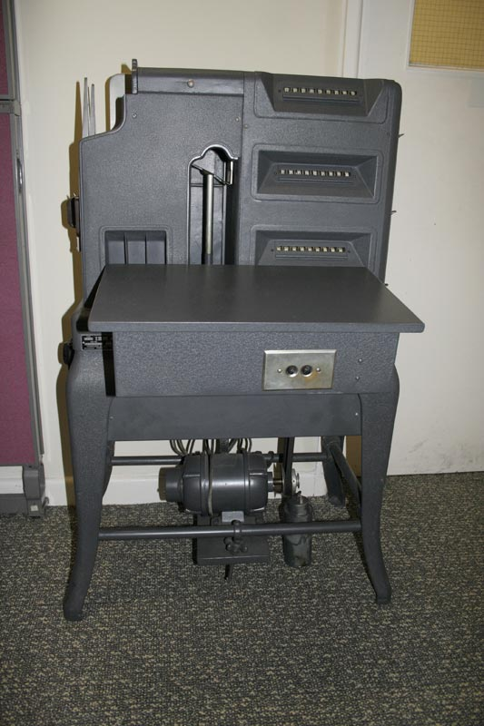
- The artefacts mentioned in the last report from Lyngby, Denmark, were delivered early January. The highlight is an IBM 091 "Hollerith Type III Tabulator" which dates from 1921 and is in excellent condition. The shipment also contained two Executive typewriters.
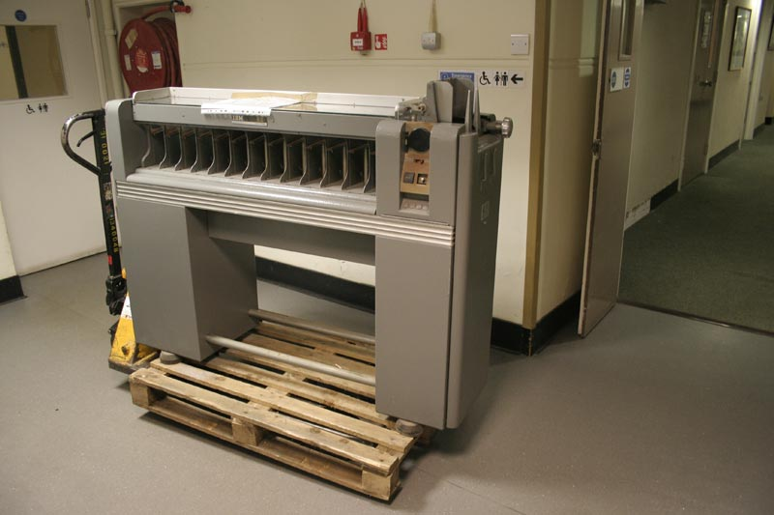

- The 082 card sorter has been delivered from Greenock.

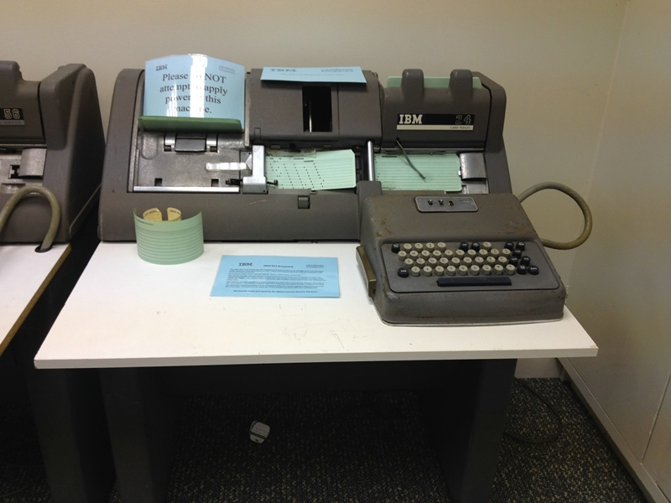
- The 024 card punch is now in full working order. It and its companion 056 verifier have been fitted with home-made table tops and rear covers, and work has commenced on the 056. Mechanical clean, lubricate and adjust is completed, but unfortunately we have noticed that one of the post-office type relays has been damaged and is missing the armature. We are on the look-out for a replacement.

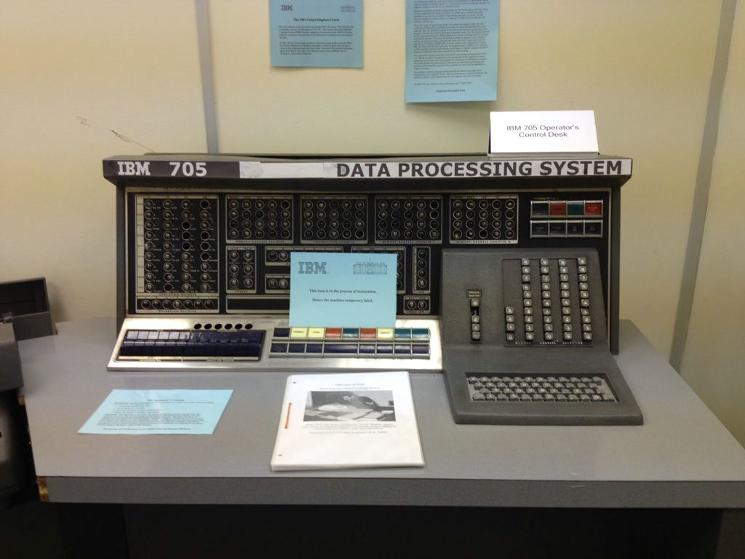
- The covers of the 705 console have now been straightened. We have designed a machine identification plate in Photoshop and are printing, laminating and fitting to the console. The photograph shows the prototype plate. We have also designed a 3D model of a missing key top and ordered a 3D print to fill the gap.

- The 1980s model of the Hursley site, which has long been located in the conservatory at the side of Hursley House, has been moved to the museum. This necessitated quite a bit of shuffling around of exhibits to accommodate it.

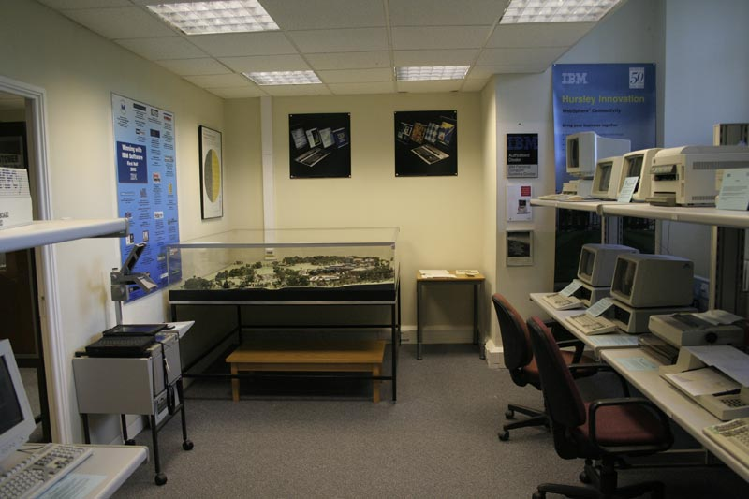
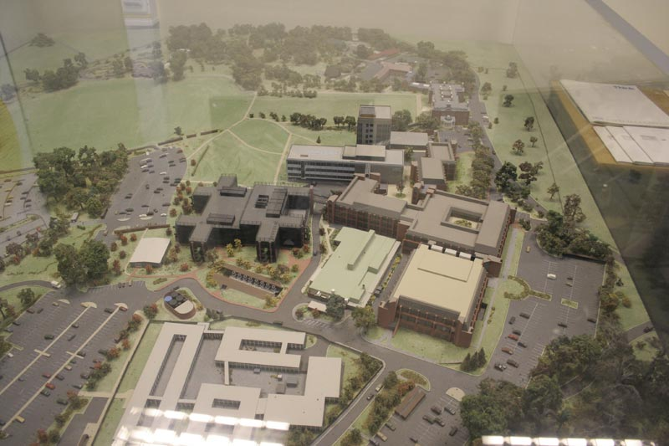

Disposals
We are disposing of spare copies of some books, if any of you are interested:

McGraw Hill Encyclopaedia of Science & Technology
6th edition 1987, volumes 1 - 20

Advances in Computers, Marshall C Yovits / Academic Press
Volumes 1 (1960) - 19 + 22, + 34 - 39 (1994)

Britannica 15th Edition 1988 - Index (2 volumes), 1988 Annual, Micropedia (1-12), Macropedia (13-29), Propaedia Guide, Yearbooks 1983 / 84 / 86-88 / 90, Book of the Year 1982 / 84-92

Charles Babbage Institute Reprint for the History of Computing
Volume 14, MIT Press 1989

McGraw Hill Concise Encyclopaedia of Science & Technology
Second edition 1989

Due to the weight I guess collect only - includes guided tour of the museum!

